Interface Arduino with Node-RED to monitor the Temperature and Humidity on a Webpage
Name – Dibyajyoti Swain
Roll NO – 1ETMCA20251009
Hardware Requirment – Arduino Uno R3 board, DHT 11 sensor, 3 jumper wire, USB a to b cable.
Software Requirment – Arduino IDE, NODE JS
Step 1: Arduino Setup
- First download the Arduino IDE software from google for windows. Then open it and go to the library section and download DHT Sensor Library Then Connect the DHT11 sensor to your Arduino. The DHT11 has three pins:
  - VCC to 3.3V/5V
  - GND to GND
  - DATA to digital pin 3 ( or any other pin, here in this code we have connected to pin number 3)
- Arduino Code: Upload the following code to your Arduino board. This will read the humidity and temperature data from the DHT11 sensor and send it via serial communication to Node-RED.
// Read DHT11 sensor and send serially to PC

#include <DHT.h> // Include Adafruit DHT11 Sensors Library

#define DHTPIN 2 // DHT11 Output Pin connection
#define DHTTYPE DHT11 // DHT Type is DHT11

DHT dht(DHTPIN, DHTTYPE); // Initialize DHT sensor

void setup () {
dht.begin();
Serial.begin(9600); // To see data on serial monitor
}

void loop (){

float H = dht.readHumidity(); //Read Humidity
float T = dht.readTemperature(); // Read temperature as Celsius

// Check if any reads failed and if exit
if (isnan(H) || isnan(T)){
Serial.println("Failed to read from DHT sensor!");
return;
}

// Combine Humidity and Temperature into single string
String dhtData = String(H) + "," + String(T);
Serial.println(dhtData);
delay(2000); // Wait two seconds between measurements
}
Step 2: Node-RED Setup
1. Install Required Nodes
Make sure that the Node-RED Dashboard nodes are installed. You can install them by running the following command in the Node-RED command line:
npm install node-red-dashboard
2. Create a New Flow
Open Node-RED and create a new flow. Use the following components:
- Serial In Node: Configure it to read from the correct serial port where your Arduino is connected (e.g., COM11). Set the baud rate to 9600.
  - Add the node and name it "Arduino Uno R3".
- Function Node: Add a function node and insert the following code to process the incoming serial data. Add this code into the function node on message section.
- var m = msg.payload.split(',');

- // Ensure the data is properly split and contains two values
- if (m.length === 2) {
- // Parse the humidity (first value) and temperature (second value)
- var H = { payload: parseFloat(m[0]) }; // Humidity
- var T = { payload: parseFloat(m[1]) }; // Temperature

- // Return humidity and temperature as separate messages
- return [H, T];
- } else {
- // If the data doesn't contain two values, return null to indicate a problem
- return null;
- }

- Debug Node: Connect it to the output of the serial node to check if data is flowing correctly.
- Gauge Nodes:
  - Add two gauge nodes, one for humidity and another for temperature.
  - Humidity Gauge:
    - Set the title to "Humidity".
    - Set the value format to {{value}}%.
    - Set the minimum value to 0 and the maximum to 100.
  - Temperature Gauge:
    - Set the title to "Temperature".
    - Set the value format to {{value}}ºC.
    - Set the minimum value to 0 and the maximum to 100.
- Wire the Nodes:
  - Connect the Serial In node to the Function Node.
  - Connect the first output of the function node to the Humidity Gauge node.
  - Connect the second output of the function node to the Temperature Gauge node.
An Overview of the flow structure:
- Serial In Node (Arduino Uno R3): Reads data from the serial port.
- Function Node: Splits the serial data into humidity and temperature values.
- Gauge Nodes: Display the data on a dashboard.

The flow is structured as follows:
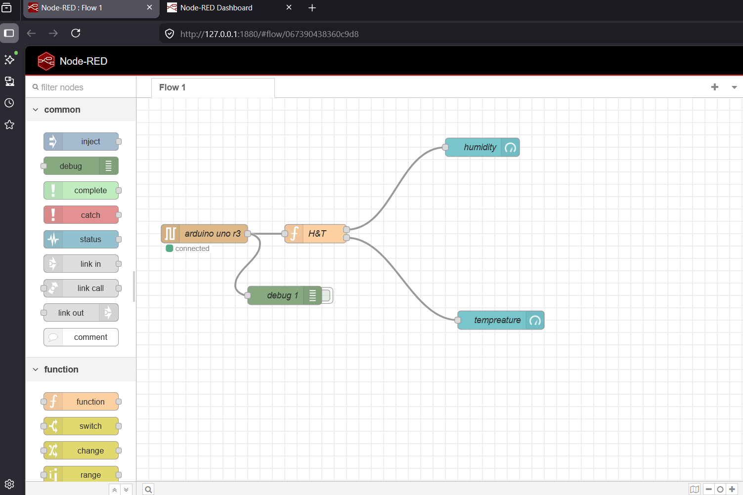
Step 3: Deploy and Test
- Deploy the flow in Node-RED.
- Open the Node-RED dashboard (usually available athttp://127.0.0.1:1880/ui).
- Check the Gauges: You should see live humidity and temperature readings from the DHT11 sensor displayed in the dashboard.
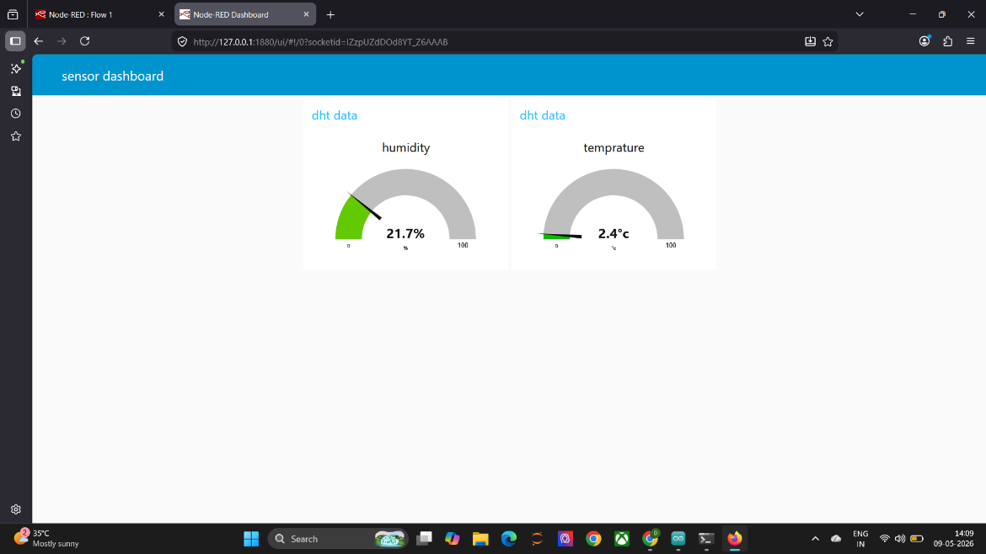

The Arduino code is:-
